BROADMEADOWS SDS
Yard Duty and Supervision Policy

Purpose
To ensure school staff understand their supervision and yard duty responsibilities.

Scope

This policy applies to all teaching and non-teaching staff at Broadmeadows SDS, including education support staff, casual relief teachers and visiting teachers.

Policy
Appropriate supervision is an important strategy to monitor student behaviour and enables staff to identify and respond to possible risks at school as they arise. It also plays a vital role in helping schools to discharge their duty of care to students.
The Principal is responsible for ensuring that there is a well organised and responsive system of supervision and yard duty in place during school hours, before and after school, and on school excursions and camps and other school activities.
School staff are responsible for following reasonable and lawful instructions from the Principal, including instructions to provide supervision to students at specific dates, times and places. Supervision should be undertaken in a way that identifies and mitigates risks to child safety.

Before and after school
Broadmeadows SDS’s grounds are supervised by school staff from 8:50am until 3:30pm. Outside of these hours, school staff will not be available to supervise students.
Parents and carers will be advised regular reminders in our newsletter that they should not allow their children to attend Broadmeadows SDS outside of these hours.
If a student is not collected before supervision finishes at the end of the day, the Principal or nominee staff member will attempt to contact the parents/carers.
Should parents/carers be unable to be contacted, the Principal or nominee staff member will consider whether it is appropriate to:
- attempt to contact the emergency contacts
- contact Victoria Police and/or Child Protection to arrange for the supervision, care and protection of the student.

Yard duty
All staff at Broadmeadows SDS are expected to assist with yard duty supervision and will be included in the weekly roster.
The Assistant Principal and Daily Organisers are responsible for preparing and communicating the yard duty roster on a regular basis. At Broadmeadows SDS, school staff will be designated a specific yard duty area to supervise.
Yard duty zones
Dimboola Campus
Zone | Area
Early Years | - EY Pirate Ship  - EY Sandpit  - EY Roaming  - EY Shade Play
Sensory Yard | - Roaming  - Trampoline
Middle Years | - MY Courts  - MY Sandpit  - Mod Hall Play Club  - MY Trampoline  - MY Roaming  - Blue Building Play Club  - MY Sensory

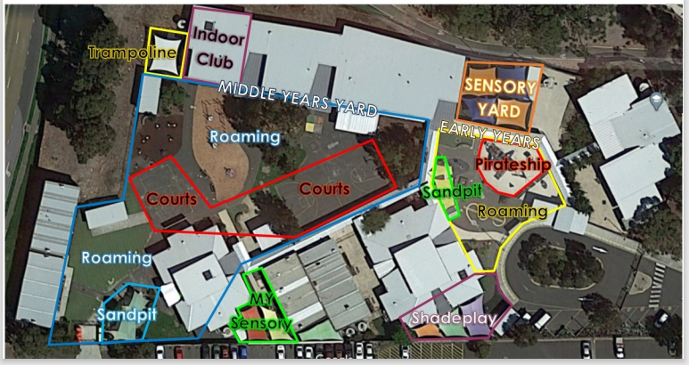
Sorrento Campus
Zone | Area
Sorrento Yard | - Gym to Grass  - Trampoline  - Undercover Shelter  - Roaming  - Rm #15 Indoor Play club
Dimboola Yard | - Art Area & Basketball  - Pergola Area  - Garden & Ping-Pong  - Indoor Play club  - Roaming
Quiet Yard | - Outdoor Spaces

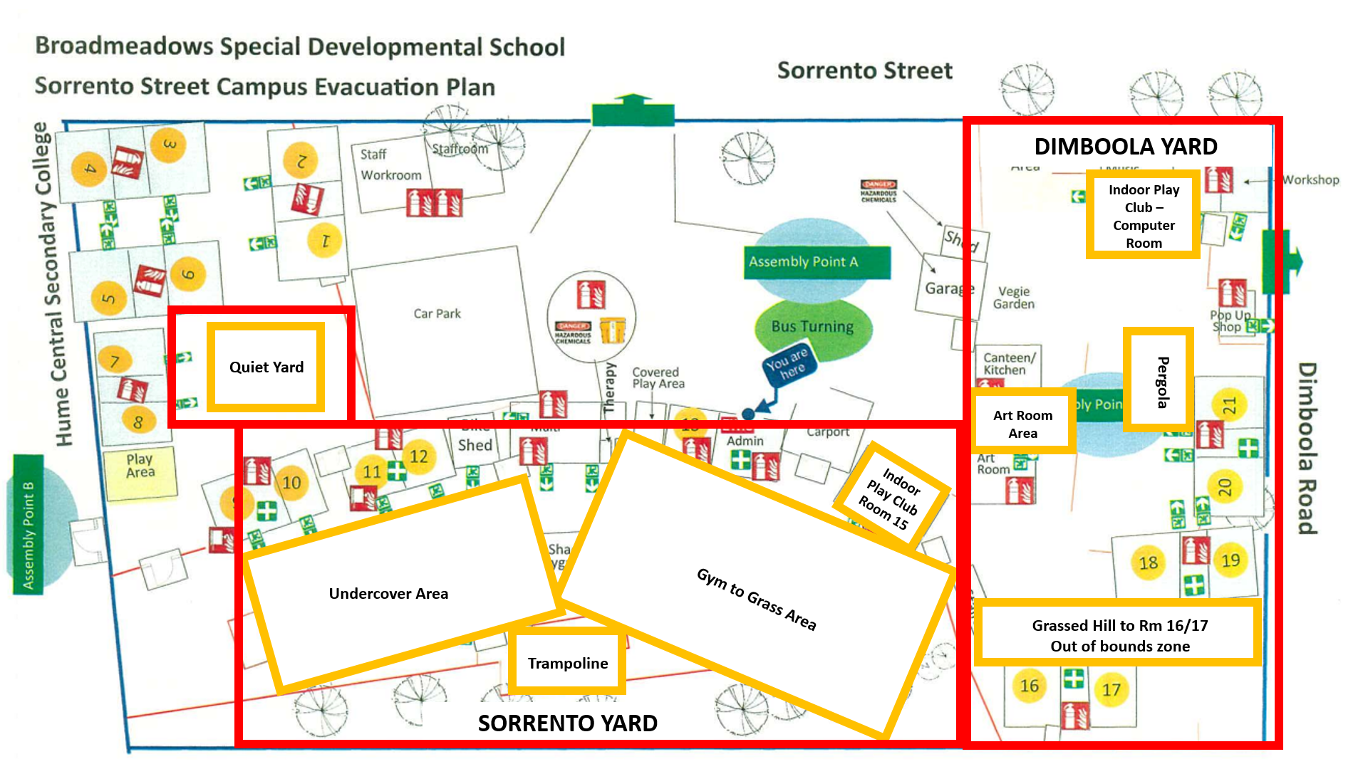
Yard duty equipment
School staff must:
- wear a provided safety/hi-vis vest whilst on yard duty. Safety/hi-vis vests will be stored [insert detail]
- wear a hat in Term 1 & Term 4
Yard duty equipment must be returned after the period of supervision or handed to the relieving staff member.
Yard duty responsibilities
Staff who are rostered for yard duty must remain in the designated area until they are replaced by a relieving staff member.
During yard duty, supervising school staff must:
- methodically move around the designated zone ensuring active supervision of all students
- ensure students remain in their designated play areas
- be alert and vigilant
- intervene immediately if potentially dangerous or inappropriate behaviour is observed in the yard
- ensure that students who require first aid assistance receive it as soon as practicable
If being relieved of their yard duty shift by another staff member (for example, where the shift is ‘split’ into 2 consecutive time periods), the staff member must ensure that a brief but adequate verbal ‘handover’ is given to the relieving staff member in relation to any issues which may have arisen during the first shift.
If the supervising staff member is unable to conduct yard duty at the designated time, they should contact the Assistant Principal with as much notice as possible prior to the relevant yard duty shift to ensure that alternative arrangements are made.
If the supervising staff member needs to leave yard duty during the allocated time, they should contact the Assistant Principal or Learning Specialist but should not leave the designated area until the relieving staff member has arrived in the designated area.
If the relieving staff member does not arrive for yard duty, the staff member currently on duty should send a message to the office/call Assistant Principal or Learning Specialist and not leave the designated area until a relieving staff member has arrived.
Students will be encouraged to speak to the supervising yard duty staff member if they require assistance during recess or lunchtime.

School activities, camps and excursions
The Principal and leadership team are responsible for ensuring that students are appropriately supervised during all school activities, camps and excursions, including when external providers are engaged to conduct part or all of the activity. Appropriate supervision will be planned for school activities, camps and excursions on an individual basis, depending on the activities to be undertaken and the level of potential risk involved, and will follow the supervision requirements in the Department of Education and Training Excursions Policy.

Digital devices and virtual classroom
Broadmeadows SDS follows the Department’s Cybersafety and Responsible Use of Technologies Policy with respect to supervision of students using digital devices.
Broadmeadows SDS will also ensure appropriate supervision of students participating in remote and flexible learning environments while on school site.

While parents are responsible for the appropriate supervision of students accessing virtual classrooms from home:
- student attendance will be monitored
- any wellbeing or safety concerns for the student will be managed in accordance with our usual processes – refer to our Student Wellbeing and Engagement Policy and our Child Safety Responding and Reporting Policy and Procedures for further information.

Supervision of student in emergency operating environments
In emergency circumstances our school will follow our Emergency Management Plan, including with respect to supervision.
In the event of any mandatory period of remote or flexible learning our School will follow the operations guidance issued by the Department.
COMMUNICATION

This policy will be communicated to our school community in the following ways:

- Included in staff induction processes
- Discussed at staff briefings or meetings, as required
- Made available in hard copy from school administration upon request
Information for parents and students on supervision before and after school is available on our school website and parent reminders are sent at the beginning of each term in our school newsletter.

Further Information and Resources
- the Department’s Policy and Advisory Library (PAL):
  - Child Safe Standards
  - Cybersafety and Responsible Use of Technologies
  - Duty of Care
  - Excursions
  - Supervision of Students
  - Visitors in Schools

POLICY REVIEW AND APPROVAL

Policy last reviewed | September 2022
Approved by | Principal
Next scheduled review date | September 2024

This policy will also be updated if significant changes are made to school grounds that require a revision of Broadmeadows SDS’s yard duty and supervision arrangements.

